**EXPERIMENT-3**

**Title:** To understand and use SQL Sub-Query

**Objective:** To understand the use of sql subquery.

**1. Create the following table.**

(a) Supplier-(scode,sname,scity,turnover)

Code:

use lab_work;

create table Supplier (

Scode varchar(10) primary key,

Sname varchar(50),

Scity varchar(20),

Turnover int

);

(b) Part-(pcode,weigh,color,cost,sellingprice)

Code:

use lab_work;

create table Part(

Pcode varchar(10) primary key,

Weigh varchar(20),

Color varchar(30),

Cost decimal(8,2),

Sellingprice decimal (8,2)

);

(c) Supplier_Part-(scode,pcode,qty)

Code:

use lab_work;

create table Supplier_Part (

Scode varchar(10) references Supplier(Scode),

Pcode varchar(10) references Part(Pcode),

Qty int,

primary key(Scode,Pcode)

);

**2. Populate the table**

(a) Supplier

Code:

use lab_work;

INSERT INTO Supplier

VALUES ('A0001','Haseen', 'Dehradun',50000),

('A0002','Kishore','Delhi',1500000),

('A0003','Gaurav','Mumbai', 200000),

('A0004','Rachit', 'Mumbai',5400000),

('A0005', 'Ritvik', 'Chennai',800000),

('A0006','Akshay', 'Mumbai', 7900000),

('A0007','Ajay', 'Delhi' , 90000),

('A0008','Pal', 'Mumbai',5500000);

(b) Part

Code:

use lab_work;

INSERT INTO Part

VALUES ('P0001','26','Black','100','120'),

('P0002','27','White','80','150'),

('P0003','37','Red','75','130'),

('P0004','40','Blue','70','100'),

('P0005', '28','Green', '20', '120'),

('P0006', '32', 'Yellow','30','85'),

('P0007', '34', 'Orange', '40','78'),

('P0008', '29', 'Grey', '45', '200');

(c) Supplier_part

Code:

use lab_work;

INSERT INTO Supplier_Part

VALUES ('A0001','P0001',500),

('A0002','P0002',1000),

('A0003','P0003',200),

('A0004','P0004',250),

('A0005','P0005',400),

('A0006','P0006',350),

('A0007','P0007',850),

('A0008','P0008',650);

Output

Code:

use lab_work;

select * from Supplier;

select * from Part;

select * from Supplier_Part;

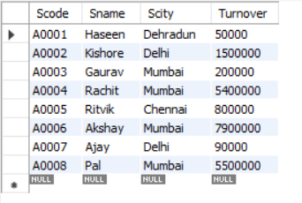

**Supplier**

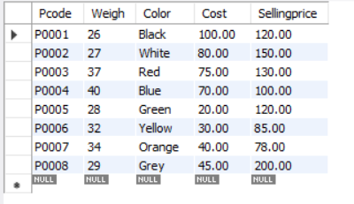

**Part**

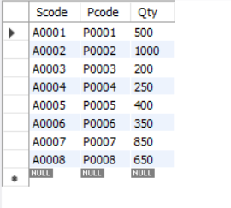

**Supplier_part**

**3. Write appropriate SQL Statement for the following:**

1. Get the supplier number and part number in ascending order of supplier number

Code:

use lab_work;

select Scode, Pcode from supplier_part order by Scode;

Output:

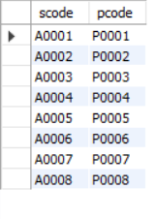

2. Get the details of supplier who operate from Bombay with turnover 50.

Code:

use lab_work;

select * from supplier where Scity = 'Mumbai' and Turnover='200000';

Output:

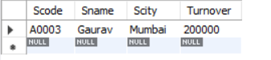

3. Get the total number of supplier.

Code:

use lab_work;

select count(sname) from supplier;

Output:



4. Get the part number weighing between 25 and 35.

Code:

use lab_work;

select Pcode from part where Weigh between 25 and 35;

Output:

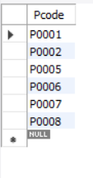

5. Get the supplier number whose turnover is null.

Code:

use lab_work;

select Scode from supplier where Turnover='null';

Output:

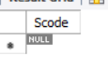

6. Get the part number that cost 20, 30 or 40 rupees.

Code:

use lab_work;

select pcode from part where cost in (20,30,40);

Output:

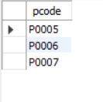

7. Get the total quantity of part 2 that is supplied.

Code:

use lab_work;

select Qty from supplier_part where Pcode='P0002';

Output:

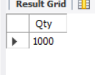

8. Get the name of supplier who supply part 2

Code:

use lab_work;

select sname from supplier where scode =

(select scode from supplier_part where pcode='P0002');

Output:

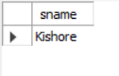

9. Get the part number whose cost is greater than the average cost.

Code:

use lab_work;

select pcode from part where

cost > (select avg(cost) from part);

output:

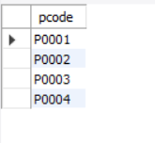

10. Get the supplier number and turnover in descending order of turnover.

Code:

use lab_work;

select Scode, Turnover from supplier order by Turnover desc;

Output:

